THE SECTIONS IN YELLOW WILL BE EDITED BY THE EDITORIAL TEAM. Do not modify them, please.

**This first page should be read carefully, but completely removed before submitting the manuscript.**

**Important notes for the authors.**

We remind you that the absence of publication and subscription costs to the journal implies that the work of the Editorial Team is focused on guaranteeing the quality of the content, **with the authors being the ones who must carefully adhere to the format rules**, presenting, therefore, *camera-ready* items; observing this basic principle avoids returns and delays that neither publishers nor authors want.

* The journal adheres to the **International System (SI)** in terms of units, symbols, etc. Therefore, the symbol for kilometer must be written km (in lower case, without a period, except when it is the end of the line). In the graphic scales, **km** should also be written, not "KM" or "Km", or "kms", or "km."
* A space must always be kept between quantities and unit symbols (*e.g.,* **50 km**); note that this applies, also according to SI, to **percentages** and **degrees** **Celsius**: 20 %, 12 °C. The only exception to this mandate refers to angular degrees (or hours), minutes and seconds, in which such a space should not be placed (*e.g.,* 12° 20' 30”). In order to prevent a quantity from remaining at the end of a line and the unit abbreviation at the beginning of the next, the spaces between quantity and symbol will always be non-separating, also called “hard space”; in Microsoft Word, the keyboard shortcut Shift+Ctrl+Space allows you to insert this **non-breaking space**.
* Also, according to SI:
  + It will be valid to use, as a decimal separator, both the point and the comma. Regardless of the choice made by the authors (point or comma), **consistency must be maintained** throughout the **text**, **graphs**, **tables** and **maps** of the article.
  + **It is not recommended** to use the point nor the comma as a thousands separator. Instead, a non-breaking space (described in the previous point) is advised: 300  000 km s-1. Exceptionally, a comma may be used when the decimal separator is clearly a point, although the preference remains for the non-breaking space (or for not applying any thousands separator). It is advised not to use thousands separator when the amount does not exceed 9999.
* Maps, graphs, etc, must have sufficient resolution for clear and comfortable reading.
* Citations and references should follow the formatting style of the journal. In citations, “*et al.*” will be written in italics [[RAE](http://aplica.rae.es/orweb/cgi-bin/buscar.cgi)].
* A check should be made looking for unnecessary duplicate or triplicate spaces.

Failure to follow the formal rules of the journal (those just posted and those available on the website regarding anonymous review, etc) may lead to the exclusion of the work from the review list by the Editorial Team.

# TITLE OF THE ARTICLE [Times New Roman 11 points, bold, centered single spacing, line 5]

IMPORTANT NOTE 1: Do not include the name, affiliation or email of the authors, neither here nor in the page headers. Just leave what is written in a generic way to ensure anonymous review. **Delete this NOTE 1 after reading.**

IMPORTANT NOTE 2: For the same purpose of guaranteeing an anonymous review, before sending the manuscript and once the word processor is closed, edit its metadata (usually with the right mouse button on the file name) to completely eliminate the details of the authors (see [Instructions_BlindPeerReview_ENG.pdf](https://www.geofocus.org/Instructions_BlindPeerReview_ENG.pdf) for details). Also delete this NOTE 2

ABSTRACT

The abstract can briefly explain the objectives, methodology and main results obtained in the article. Stick to about 150 to 250 words, in a single paragraph. As a font for the text in general, Times New Roman 11 pt is established.

Keywords: Between two and six keywords separated by a semicolon followed by a space will be included.

TITLE IN SPANISH

RESUMEN

Same rules than for the “ABSTRACT”, but in Spanish.

Palabras clave: Same rules than for the “Keywords”, but in Spanish.

**1. Introduction: First level section title, bold**

This section presents the topic or problem addressed in the article, as well as its interest; To do this, the theoretical, methodological or empirical background of said topic or problem is summarized and discussed. The discourse will typically lead to the elaboration of hypotheses and/or to specify the objectives of the investigation. It is also convenient to allude to the possible usefulness of what is intended to contribute, as well as to anticipate the structure of the article.

Footnotes should be avoided in this and the other sections.

A typical structure for a scientific article in GeoFocus is suggested below, but it should be understood that each author can organize the article into the sections that best explain the research carried out.

**2. Materials, data and methods**

This section specifies the methodology adopted in the research.

2.1. The case study. Second level section

2.1.1. Spatial delimitation. Third level section title

In this third level section, the geographical scope of study is presented and justified.

2.1.2. Temporary delimitation. Third level section title

The time period examined is justified and specified.

2.2. The data. Second level section title

The origin and obtaining of geodata, statistical sources, quality, errors, etc, including those that come from direct acquisition, are described.

2.3. Materials and analysis techniques. Another second level section

In this section, the materials used are presented, if relevant, and mathematical formulations that the adopted analysis method entails are illustrated. The formulas must be elaborated with the equation editor available in the word processor.

If applicable, the demonstration or illustration of formulas can be referred to appendix 1.

*A) Fourth level subsection title (italics)* If necessary, this level of detail can be used, although it is not advisable to dwell on it.

*B) Another fourth level subsection*

References in the text to authors will follow the convention (Surname, 1991) for one author, (Surname_1 & Surname_2, 1991) for two authors, Surname *et al*. (1991) for more than two authors. It is also possible to cite what that author has verified. Examples: “according to Surname (1995)…”, “according to Surname *et al*. (1991)”.

Below is the format for the tables (with the appropriate lines for a correct understanding) and in a centered position. They must be placed within the text, in a close position (preferably after) to the mention of them.

The same number of decimal places must be maintained in each column of the tables, avoiding the suppression of zeroes in decimal places that are significant. It is highly recommended to align amounts to the right, or to use a fixed-pitch font (such as Courier New) if not.

**Table 1. Title of the table [Times New Roman, 11 points, bold, centered]**

|  |  |  |
| --- | --- | --- |
| Header | Header 2 | |
|  | Header | Header |
| Class 1 | 54 | 12.37 |
| Class 2 | 36 | 7.10 |

Source: own elaboration based on data from the 1996 Population Register. Institute of Statistics. [Times New Roman, 10 points centered]

**3. Description and analysis of results. First level section title**

This section systematically presents and interprets the results obtained. All images, graphs and maps will be called figures and will be numbered.

The size of the figures must be sufficient for their correct reading. If necessary, the figures can be placed in a full-page appendix. This possibility may be especially appropriate in complementary maps, or that must be displayed at the maximum possible size.

It is important to cite or refer to the figures, for example in this way: (see Figure 1). The figure will go within the text in a close position (preferably after) to the first mention of it.

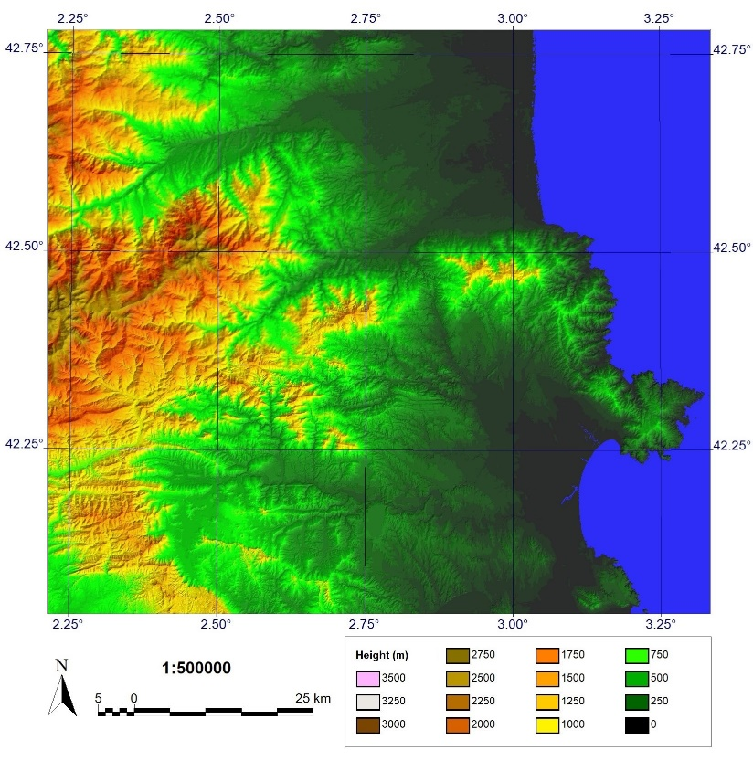

**Figure 1. Explanatory caption of the figure in Times New Roman, 11 points, bold and centered.**

Source: data source and authorship can be added. [Times New Roman, 10pt. centered]

**4. Discussion and assessment of findings**

In this section, the results of this research are examined comparatively with those of other authors, to show the net contribution made, the corroboration of other studies, the discrepancies with them, etc.

**5. Conclusions**

An overall balance is made of the extent to which the objectives have been achieved and what the most important conclusions are. Outstanding issues, limitations… may also arise.

**6. Acknowledgments**

If appropriate, institutional and/or personal acknowledgments are reflected here. The sources of financing can also be entered here with their references, if any. Avoid personal references in the first submission to guarantee double blind revision.

**References [Times New Roman, 11 pt. Bold font]**

**Important:** single line spacing, but for paragraphs adopt a trailing spacing of 6 pt. Pay attention to punctuation and spelling!

Surname, N. (year). *Title of the book in italics and lowercase*. City, Publisher.

Surname, N. (year). “Title of the article in lowercase”, *Name of the Journal in italics*, number, volume, pp. from-to. **DOI**

(*e.g.*, González, D., Cifuentes, V.J., Sancho, A. (2019). Spatial data infrastructures at the service of water management. The case of the Guadalquivir Hydrographic Confederation. *GeoFocus*, 24, 3-17. https://dx.doi.org/10.21138/GF.548)

Surname, N. (year). “Book chapter title in lowercase”, in Surname, N. (Ed.): *Title of the collective work in lowercase and italics*. City, Editorial, pp. from-to.

Surname, N. (year). *Title of the electronic or internet document in italics*. City, Publishing entity. [accessed dd-mm-yyyy]. Available at [www.yyyyy.html](http://www.yyyyy.html)

# APPENDIX 1 [title font size 11 points, bold]

If it is convenient, appendices can be added for the development of formulas, algorithms, large tables or other purposes, in order to eliminate more technical issues from the text of the article, for example.